**Chapter 1 – Installing the Application and Preparing for Use**

**Step 1 - Unzip the file**

* Unzip the application file to the folder of your choice, typically this is the “My Documents” folder.
  + Right click on the zip file and select “Extract All…”
* Double click to open the folder named “CapPlanningWin” just created from the zip file.
* Right click on “capitalplanning.exe” and click “send to Desktop (create shortcut)”
  + Now you can run the application from either location.
* Before running the application, proceed to the next step

**Step 2 - Fixed Asset Data and Summary Maintenance Data – This data is used for trending and calculating total costs compared to asset value.**

This tool is intended to help managers understand the cost of maintenance and to help with an organizations Capital Planning process. For this to happen, annually the data set is updated with fixed asset data provided from Accounting coupled with summary maintenance data. To simplify the process two templates and reports for Express Maintenance have been provided and located in the datafilesfolder.

**Express Maintenance Summary Data**

* From Express Maintenance we need to gather summary costs for PMs and Demand work orders. We will compile the data using the “Units Expense Summary – GW” report (provided) **DO NOT CHANGE THE COLUMN NAMES**:
  + Import the report template by going to Maintenance Reports then on the public tab right click, select import report, browse to report mentioned above highlight the file and click open or ok.
  + Data will be summarized from no date 1 year before current year. (This will be performed twice annually, once to summarize PM costs and once to summarize Demand maintenance (non-PM) costs)
  + Example: I am installing the capital planning system today 6/5/2018, export all EM data for all assets from as early as possible to 12 months from current date in this case 6/5/2017 ~~from 12/31/2016~~. This data can be exported with the supplied “Units Expense Summary – GW” Report.
    - Use the filters to set the completed date as determined in previous step.
    - Use ~~WoClass~~ WO Category Filter and choose “Planned - Proactive”
    - 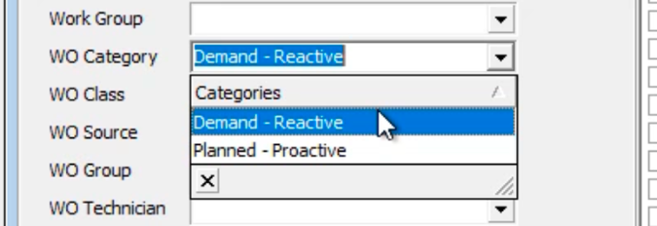
      * Run the report
      * Export the data to a .csv file, note what you name and where you save the file.

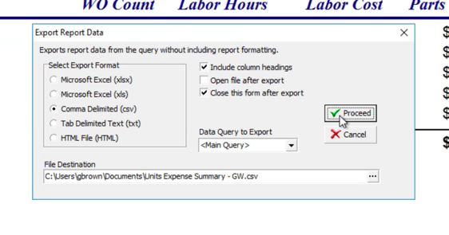

* + - Repeat the previous four steps for ~~WoClass~~ WO Category Filter and choose “Demand - Reactive”, on second iteration don’t overwrite previous export.
  + Using the “FixedAssetLedger2018.csv” file provided in the data files folder fill in the following columns:
    - Unit Number = Unit, Unit Description = Unit Name, Total PM COST = Sum_WoMaster_TotalCosts (WO Category = “Planned - Proactive”), Total Maint Costs ~~Yr-2~~ = Sum WoMaster_TotalCosts (WoClass = “Demand - Reactive”)

**Fixed Asset Ledger Data**

* From accounting collect the following for each asset entered previously in the provided file named “FixedAssetLedger2018.csv” **DO NOT CHANGE THE COLUMN NAMES**: All columns should be populated, if you don’t know the value use 0, * requires a value.
  + **AssetID** – This is the unit number used by accounting. If it differs from the unit number in Express Maintenance. It should be entered in “User Defined Field 21” on the “Units” page and “User Defined” tab of Express Maintenance.
  + **Total Asset Value \***– This is the all-in installation value of the asset. it should be summarized to reflect the total initial install value at the start of the depreciation cycle.
  + **Current Book Value** *– The current depreciated value of the asset. If other capital projects are involved with this unit, repairs, etc.. they should be summarized and represented as a single unit.
  + **Install Date** – The date the asset was commissioned and should match the data in Express Maintenance. If not adjust as required.
  + **Useful Life** – This is the depreciable life of the asset / unit, based on the factors determined by your organization.
  + **Expected Replacement Cost** *– This is the cost to replace the unit in todays dollars. If this value is not known, it can be estimated by compounding 3% increase in value per year from the date of installation.
  + **Salvage Value** – At the end of the usable life, the asset will have some resale or scrap value.
  + **Depreciation per Period** - What is the depreciation value per period?

**Step 3 – Collection of data for trending and forecasting**

Importing of the bulk maintenance data allows the tool to sum all of the costs in to two categories PREVENTITIVE and DEMAND. We know that preventative and predictive costs will be a part of any asset regardless of its age. But demand or reactive maintenance costs are drivers for consideration of idling or replacement. It is the DEMAND data that we will use to forecast the number of years based on the current trend as to when the cost of DEMAND maintenance will equal the replacement value of the asset or threshold percentage applied.

* For trend maintenance data:
  + Run “Units Service History-GW” report. Export the data to a .csv file
    - Import the report as stated previosly
    - Review your report to ensure the **WO Category** column classifies your work order history into 1 of 2 classifications “Demand - Reactive”or “Planned – Proactive”.
    - Export the data to a .csv file

You should have 2 .csv files ready for import

* Fixed asset ledger data with summary of **“**Planned - Proactive**”** and “Demand -Reactive” cost with all columns populated
* Bulk Units Service History data from January 1 of previous year

**Chapter 2 – Importing Data**

**Step 4 – Load data**

* Use the “Load Data” Button to access the data import screen

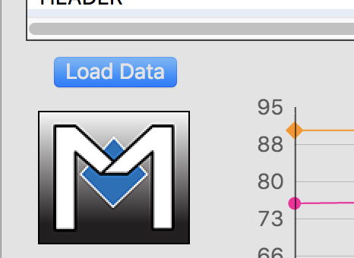

* Click on the “Import Maintenance Data” button to browse to your .csv file created in step 3, bulk maintenance data from January 1 of prior year to current.  
  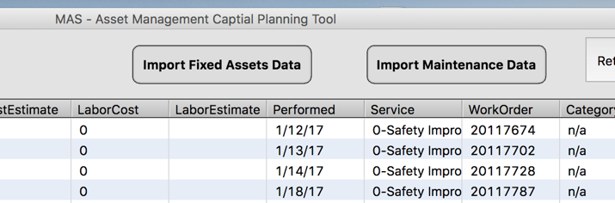
  + This could take a minute or so to complete
* Use the “Import Fixed Assets Data” button to browse to and load the fixed asset data .csv file created in step 1.
  + When completed, you will be returned to the trend screen with the application ready for use.

**Chapter 4 – Usage**

**Step 5 – Use the application**

* Select a row with the unit number of interest in the data grid

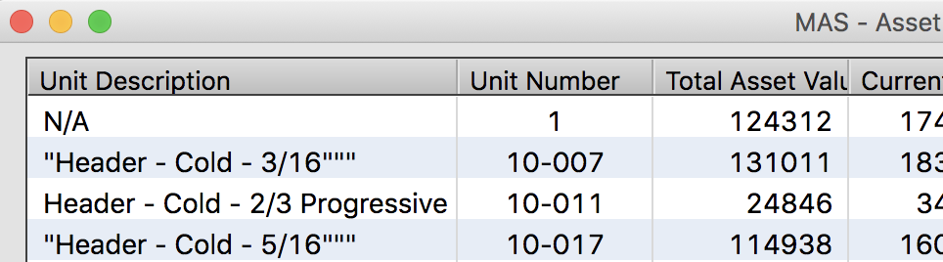

* + When you select the row, the graph will be updated automatically

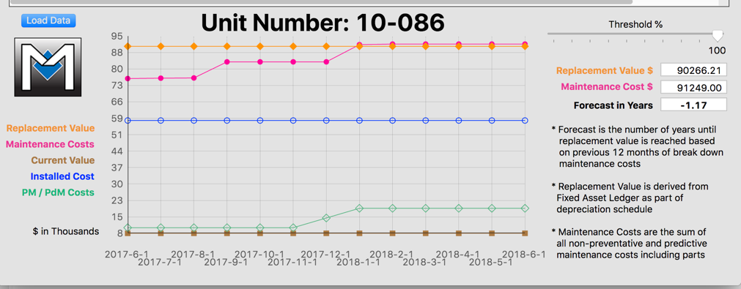

* Use the scroll bar to adjust your organization threshold of replacement value for Capital Planning.  
  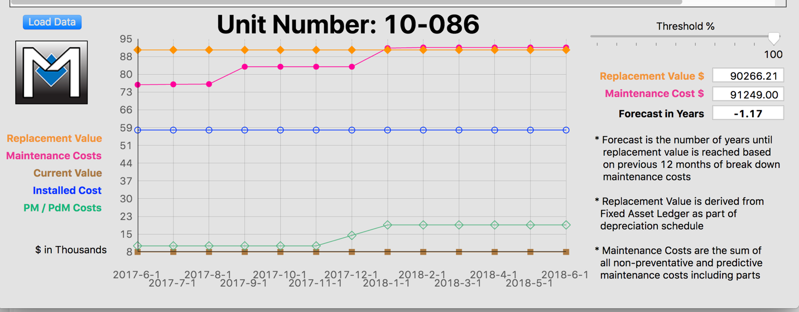
  + When the slider is positioned to a new percentage, the chart will be update accordingly as will the replacement value and forecast.

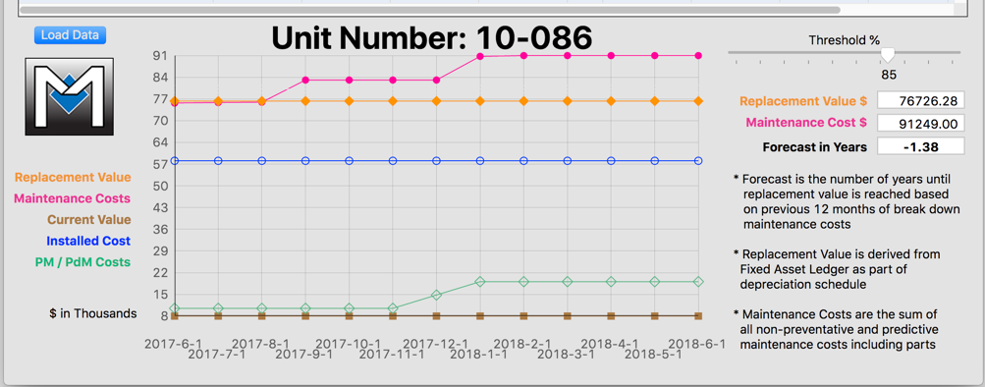

* In this example we can see that the Capital planning process was started too late and funding to replace the unit should had been request years earlier.

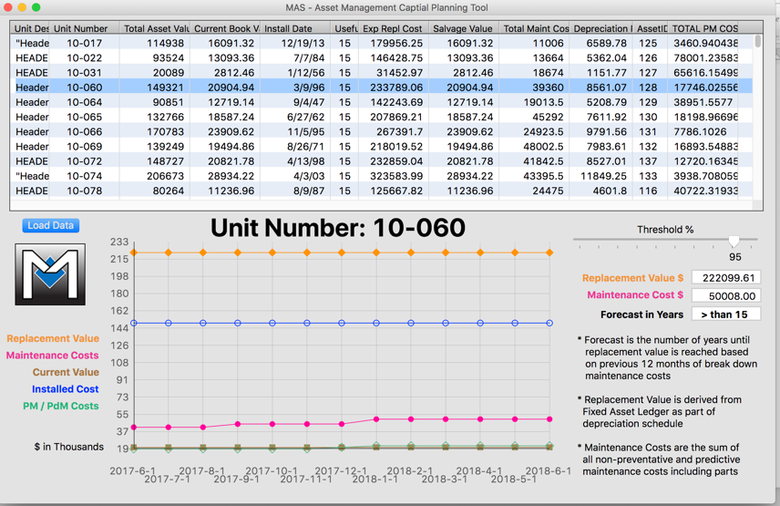

* In this example we can see that the PM costs are minimal, the demand or reactive costs are not trending out of control and we won’t exceed the replacement value within the next 15 years at the current rate despite the asset being installed in 1996.

This tool simply and quickly shows the maintenance costs compared to book value and expected replacement value to help you and your team plan and budget for Capital expenses.